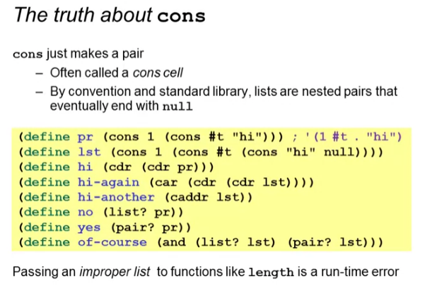

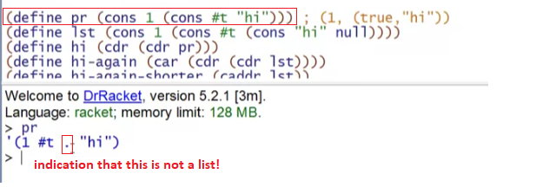

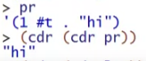

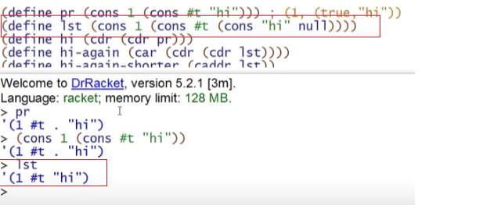



* This is the (cons “hi” null) => ‘(“hi”)
  + Getting the actual null must be (car (cdr (cdr lst))



Predefined function (caddr)

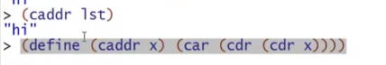

Checking whether it is a pair or a list

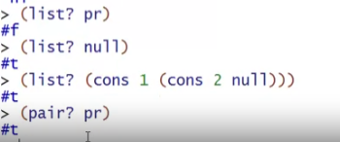



* A list can be a pair but a pair cannot be a list
  + Something will be a list if it cons on the very last a **null**
  + but all cons regarding if it cons on the very last a null or a list, is a PAIR

ERRORS

* functions for lists are not working with pairs

